1. **WRITING AN ADVERTISEMENT**

**Objective:**

To help the learner, become adept in creative writing, using imaginative and descriptive skill and create impressive advertisements that are the most successful marketing tools.

**Definition:** An advertisement is a kind of public notice given for selling or buying or providing information about persons or pets etc. Advertisements fall into two different categories- classified and commercial. Classified advertisements are more formal in tone, simple and to the point. It is never lengthy and free of designs or blocks. Clear details are to be given including the product details and contact information. Classifieds include situations vacant, sale and purchase, lost and found, educational, matrimonial and so on.

**Points to be remembered while working out an advertisement:**

1. Decide the medium of publishing the ad.
2. Relate it to the target audience. (for example, if the audience is children make it vibrant and colourful.
3. Add attention grabbing headline- exciting, emotionally compelling, sometimes it can be even shocking to make the audience curious.
4. Supporting lines must go with the headline – equally compelling.
5. It should be framed so as to create desire.
6. Add details- how to get the product.
7. Highlight the specialties.
8. Make it sound natural- the language neither too stiff nor too friendly.

**Example:**

1. **Classified Advertisement:**

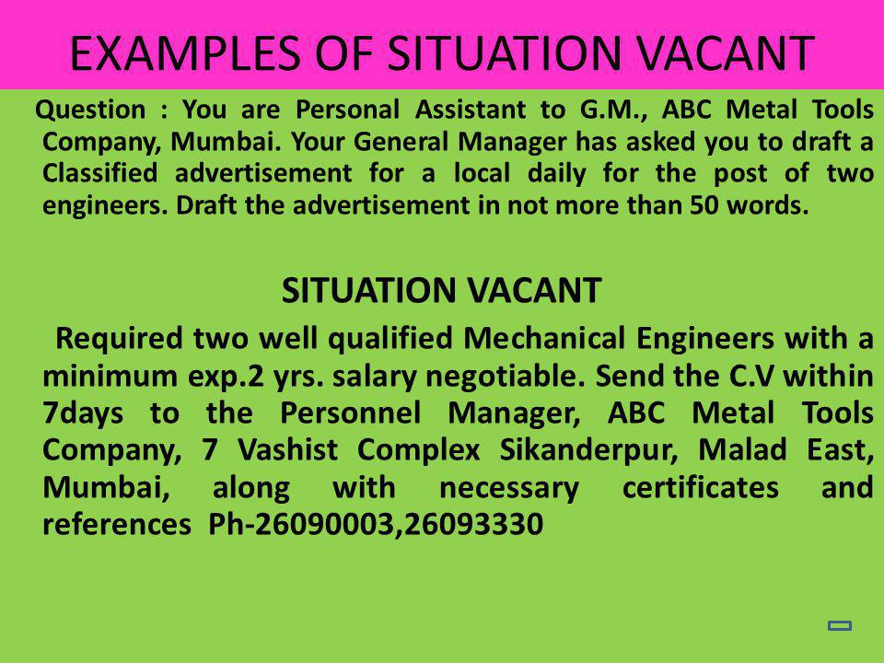

**Types of Advertisement**

|  |  |
| --- | --- |
| **Types of Advertisement** | **Purpose** |
| Situation Vacant | This advertisement is written by an employer who is looking for the services of a person in his organisation. |
| Situation Wanted | This is written by a job-seeker. |
| For Sale | This is written in an attempt to sell property, assets, office goods, etc. |
| To Let | This is written by a person looking for tenants for his/her property. |
| Accommodation Wanted | Written by the ones looking for a place for accommodation. |
| Matrimonial | This is written while looking for prospective marriage candidates |
| Missing | This is written in case any object/person/pet goes missing giving descriptive details for the same. |